**COLLOCATIONS**

Claim to, fun of, put forward, population growth, crucial to, runs in families, brain function, significant number, fact of life, distinct types, strictly speaking, considerable skill, the essentials of life, in harmony with, admit to + -ing, there's no getting away from, serve the purpose, regarded as, public performance, covered with, mistaken for, described as, respond to, known as,

|  |  |  |
| --- | --- | --- |
| **have** | **do** | **make** |
| have a bath have a drink have a good time have a haircut have a holiday have a problem have a relationship have a rest have lunch have sympathy | do business do nothing do someone a favour do the cooking do the housework do the shopping do the washing up do your best do your hair do your homework | make a difference make a mess make a mistake make a noise make an effort make furniture make money make progress make room make trouble |
| **take** | **break** | **catch** |
| take a break take a chance take a look take a rest take a seat take a taxi take an exam take notes take someone's place take someone's temperature | break a habit break a leg break a promise break a record break a window break someone's heart break the ice break the law break the news to someone break the rules | catch a ball catch a bus catch a chill catch a cold catch a thief catch fire catch sight of catch someone's attention catch someone's eye catch the flu |
| **pay** | **save** | **keep** |
| pay a fine pay attention pay by credit card pay cash pay interest pay someone a compliment pay someone a visit pay the bill pay the price pay your respects | save electricity save energy save money save one's strength save someone a seat save someone's life save something to a disk save space save time save yourself the trouble | keep a diary keep a promise keep a secret keep an appointment keep calm keep control keep in touch keep quiet keep someone's place keep the change |
| **come** | **go** | **get** |
| come close come complete with come direct come early come first come into view come last come late come on time come prepared come right back come second come to a compromise come to a decision come to an agreement come to an end come to a standstill come to terms with come to a total of come under attack | go abroad go astray go bad go bald go bankrupt go blind go crazy go dark go deaf go fishing go mad go missing go on foot go online go out of business go overseas go quiet go sailing go to war go yellow | get a job get a shock get angry get divorced get drunk get frightened get home get lost get married get nowhere get permission get pregnant get ready get started get the impression get the message get the sack get upset get wet get worried |

**Miscellaneous collocations**

| **Time** | **Business English** | **Classifiers** |
| --- | --- | --- |
| bang on time dead on time early 12th century free time from dawn till dusk great deal of time late 20th century make time for next few days past few weeks right on time run out of time save time spare time spend some time take your time tell someone the time time goes by time passes waste time | annual turnover bear in mind break off negotiations cease trading chair a meeting close a deal close a meeting come to the point dismiss an offer draw a conclusion draw your attention to launch a new product lay off staff go bankrupt go into partnership make a loss make a profit market forces sales figures take on staff | a ball of string  a bar of chocolate  a bottle of water  a bunch of carrots  a cube of sugar  a pack of cards  a pad of paper |

Entirely =different, separate, dependant  
Wildly =inaccurate, exaggerated, inappropriate, unrealistic  
Downright= wrong, dishonest, hostile, rude, disgrace, immoral  
Mildly= surprised, amused, irritated, offensive  
loosely= based, structured, connected, related  
Vaguely= familiar, aware, remember, worded, threatening do well/badly  
do someone a favour  
do some shopping  
do up (undo)  
do homework, housework, office work, work  
do a task  
make a phone call  
make a success of  
make progress  
make a noise/sound  
make a mistake  
make pizza  
make dinner  
make promises, offers, suggestions  
make a speech  
make s.o do something  
make a paper plane  
have something in common with...  
have breakfast  
have a snack  
have a coffee  
have a rest / a sleep / a nap  
have a chat  
have a meeting  
have a party  
have s.t done  
have an injection  
have an operation  
go cycling/swimming  
go for a walk  
go by car  
go abroad  
go to work/school  
go home  
go to bed  
keep a promise  
keep your cash in a safe  
keep doing something...  
keep kit  
keep in touch  
keep a promise

Some more ADVERB COLLOCATIONS:-

Highly= probable, (un)likely, successful, competitive, recommended, effective, controversial

Utterly/Absolutely = ridiculous, impossible, wrong, disgusting, devastating, pointless, appalled, worthless, senseless, hopeless

unbelievably / ridiculously / incredibly = cheap, expensive, big, small, long, short, early, late

bitterly =disappointed, resent, regret, complain, cry, weep

deeply = ashamed, concerned, moved, shocked, touched, affected, hurt, regret

strongly =oppose, influence, believe, deny, recommend, condemn, argue, object, support, suggest, correlate

**ADVERB COLLOCATIONS:**

Absurdly - low, high, easy, difficult

Widely - believed, spoken, used, distributed, known, renowned

Thoroughly - convinced, enjoyable, agree, satisfying

Fully - understand, comprehend, informed, automated, equipped

Totally and Completely - unaware, unprepared, unexpected, out of control, wrong

Patently - true, false, obvious, clear

COLLOCATIONS END

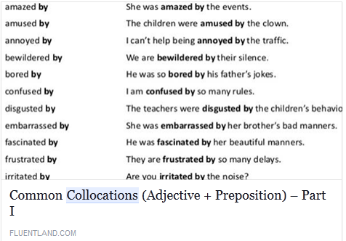

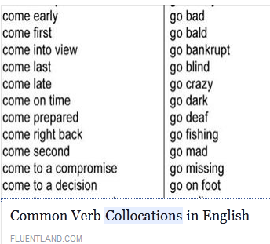

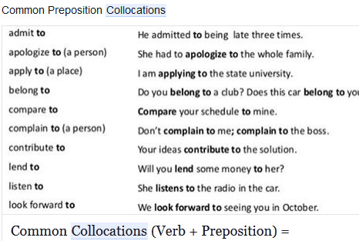

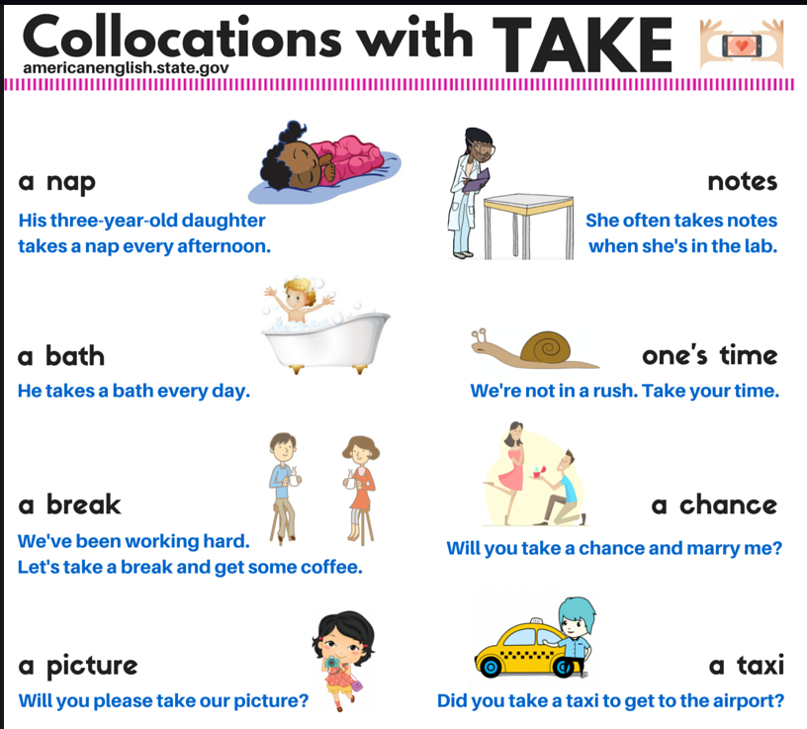

Collocations starting with the verb ‘do’  
Do me a favour  
Do the cooking  
Do the housework  
Do the shopping  
Do the washing up  
Do your best  
Do your hair  
Collocations with the verb ‘have’  
Have a good time  
Have a bath  
Have a drink  
Have a haircut  
Have a holiday  
Have a problem  
Have a relationship  
Have lunch  
Have sympathy  
Collocations with the verb ‘break’  
Break the law  
Break a leg  
Break a promise  
Break a record  
Break someone's heart  
Break the ice  
Break the news to someone  
Break the rules  
Collocations with the verb ‘take’  
Take a break  
Take a chance  
Take a look  
Take a rest  
Take a seat  
Take a taxi  
Take an exam  
Take notes  
Take someone's place  
Collocations with the verb ‘make’  
Make a difference  
Make a mess  
Make a mistake  
Make a noise  
Make an effort  
Make money  
Make progress  
Make room  
Make trouble  
Collocations with the verb ‘catch’  
Catch the bus  
Catch a ball  
Catch a cold  
Catch a thief  
Catch fire  
Catch sight of  
Catch someone's attention  
Catch someone's eye  
Catch the flu  
Collocations with the verb ‘pay’  
Pay respect  
Pay a fine  
Pay attention  
Pay by credit card  
Pay cash  
Pay interest  
Pay someone a visit  
Pay the bill  
Pay the price  
Collocations with the verb ‘keep’  
Keep the change  
Keep a promise  
Keep a secret  
Keep an appointment  
Keep calm  
Keep in touch  
Keep quiet  
Keep someone's place  
Collocations with the verb ‘save’  
Save yourself the trouble  
Save electricity  
Save energy  
Save money  
Save someone a seat  
Save someone's life  
Save something to a disk  
Save time  
Collocations with the verb ‘go’  
Go bald  
Go abroad  
Go astray  
Go bad  
Go bankrupt  
Go blind  
Go crazy  
Go fishing  
Go mad  
Go missing  
Go online  
Go out of business  
Go overseas  
Go quiet  
Go sailing  
Go to war  
Collocations with the verb ‘come’  
Come under attack  
Come close  
Come direct  
Come early  
Come first  
Come into view  
Come last  
Come late  
Come on time  
Come prepared  
Come right back  
Come to a decision  
Come to an agreement  
Come to an end  
Come to a standstill  
Come to terms with  
Come to a total of  
Collocations with the verb ‘get’  
Get the sack  
Get a life  
Get a job  
Get a shock  
Get angry  
Get divorced  
Get drunk  
Get frightened  
Get home  
Get lost  
Get married  
Get permission  
Get ready  
Get started  
Get the impression  
Get upset  
Get wet  
Get worried  
Collocations related to time  
Bang on time  
Dead on time  
Free time  
From dawn till dusk  
Great deal of time  
Early/late 15th century  
Make time for  
Next few days  
Past few weeks  
Right on time  
Run out of time  
Time goes by  
Time passes  
Waste time  
Collocations related to business English  
Annual turnover  
Keep in mind  
Break off negotiations  
Close a deal  
Close a meeting  
Come to the point  
Dismiss an offer  
Draw a conclusion  
Draw your attention to  
Launch a new product  
Go bankrupt  
Go into partnership  
Make a profit/loss

**English collocations with the word BIG**The word big is often used in collocations with a happening or event, for example:  
a big accomplishment  
a big decision  
a big disappointment  
a big failure  
a big improvement  
a big mistake  
a big surprise

**English collocations with the word GREAT**

The word great is often used in collocations with feelings or qualities.  
Great + feelings  
great admiration  
great anger  
great enjoyment  
great excitement  
great fun  
great happiness  
great joy  
Great + qualities  
in great detail  
great power  
great pride  
great sensitivity  
great skill  
great strength  
great understanding  
great wisdom  
great wealth  
English collocations with the word LARGE  
The word large is often used in collocations involving numbers and measurements.  
a large amount  
a large collection  
a large number (of)  
a large population  
a large proportion  
a large quantity  
a large scale  
English collocations with the word STRONG  
The word strong is often used in collocations with facts and opinions:  
Strong + facts/opinions  
strong argument  
strong emphasis  
strong evidence  
a strong contrast  
a strong commitment  
strong criticism  
strong denial  
a strong feeling  
a strong opinion (about something)  
strong resistance  
Strong + senses  
a strong smell  
a strong taste  
English collocations with the word DEEP  
The word deep is used for some strong feelings:  
deep depression  
deep devotion  
It is also used in these expressions:  
in deep thought  
in deep trouble  
in a deep sleep (when the person won’t wake up easily)  
English collocations with the word HEAVY  
Heavy is used for some weather conditions…  
heavy rain  
heavy snow  
heavy fog  
The word heavy is also used for people with bad habits:  
a heavy drinker  
a heavy smoker  
a heavy drug user  
There’s also the expression “a heavy sleeper” – that’s not someone who sleeps a lot; instead, it’s a person who doesn’t wake up easily when sleeping.  
The word heavy is also used in collocations with two unpleasant things: TRAFFIC and TAXES!  
heavy traffic  
heavy taxes

**ADVERB COLLOCATIONS**: Absurdly - low, high, easy, difficult  
Widely - believed, spoken, used, distributed, known, renowned  
Thoroughly - convinced, enjoyable, agree, satisfying  
Fully - understand, comprehend, informed, automated, equipped  
Totally and Completely - unaware, unprepared, unexpected, out of control, wrong  
Patently - true, false, obvious, clear

Some more ADVERB COLLOCATIONS:- Highly= probable, (un)likely, successful, competitive, recommended, effective, controversial  
Utterly/Absolutely = ridiculous, impossible, wrong, disgusting, devastating, pointless, appalled, worthless, senseless, hopeless  
unbelievably / ridiculously / incredibly = cheap, expensive, big, small, long, short, early, late  
bitterly =disappointed, resent, regret, complain, cry, weep  
deeply = ashamed, concerned, moved, shocked, touched, affected, hurt, regret  
strongly =oppose, influence, believe, deny, recommend, condemn, argue, object, support, suggest, correlate

Some collocations which i have collected Entirely =different, separate, dependant  
Wildly =inaccurate, exaggerated, inappropriate, unrealistic  
Downright= wrong, dishonest, hostile, rude, disgrace, immoral  
Mildly= surprised, amused, irritated, offensive  
loosely= based, structured, connected, related  
Vaguely= familiar, aware, remember, worded, threatening do well/badly  
do someone a favour  
do some shopping  
do up (undo)  
do homework, housework, office work, work  
do a task  
make a phone call  
make a success of  
make progress  
make a noise/sound  
make a mistake  
make pizza  
make dinner  
make promises, offers, suggestions  
make a speech  
make s.o do something  
make a paper plane  
have something in common with...  
have breakfast  
have a snack  
have a coffee  
have a rest / a sleep / a nap  
have a chat  
have a meeting  
have a party  
have s.t done  
have an injection  
have an operation  
go cycling/swimming  
go for a walk  
go by car  
go abroad  
go to work/school  
go home  
go to bed  
keep a promise  
keep your cash in a safe  
keep doing something...  
keep kit  
keep in touch  
keep a promise

Collocation is a particular combination of words that co-occur more often than would be expected by chance. For example, we use Strong Tea instead of Powerful Tea. Collocation is very much important for the reading and listening sections of PTE Academic. Here is a practice of collocation. Please write your answer in the comments.

Clues: 1- 4: fact, threat, reality, theory  
1 The authorities said the chemicals didn't pose a ................. to life.  
2 We have to take into account the ........................ of the situation.  
3 I know that what you say is true in ............... , but will it work in practice?  
4 Sadly, it seems that crime is just a .................. of life these days.

Clues: 5-8: distinct, precise, distinguished, isolated  
5 Dr. Cho's team reports that they have successfully …………. the gene that causes the disease.  
6 English essayist Joseph Addison famously wrote, "Man is ………………… from all other creatures by the faculty of laughter."  
7 He was ……………with his language, choosing his words carefully.  
8 While there are two types of camels, both are quite ………....

Clues: 9-12: saying, telling, talking, speaking  
9 Mr. Harris is not an employee here, strictly …………… , but we do hire him quite often on a freelance basis.  
10 I keep ........................ them my answer is no!   
11 Maria was …………. she might go to UCLA next semester.  
12 Our professor is quite strict and there's definitely no …………….. during his classes.

Addition Component I POS I Component II POS II  
Addition  
1 abstract adj concept n  
2 academic adj achievement n  
3 academic adj career n  
4 (in) academic adj circles n  
5 academic adj community n  
6 academic adj debate n  
7 academic adj discipline n  
8 academic adj discourse n  
9 academic adj institution n  
10 academic adj journal n  
11 academic adj life n  
12 academic adj performance n  
13 academic adj research n  
14 academic adj skills n  
15 academic adj study n  
16 academic adj success n  
17 academic adj work n  
18 academic adj world n  
19 academic adj writing n  
20 academic adj year n  
21 accept v responsibility n  
22 acceptable adjbehaviour n  
23 accurate adj assessment n  
24 accurate adj description n  
25 accurate adj information n  
26 accurate adj measurement n  
27 accurate adj picture n  
28 accurate adj record n  
29 achieve (a) v goal n  
30 achieve (an) v objective n  
31 achieve (an) v outcome n  
32 acquire v knowledge n  
33 active adj involvement n  
34 active adj participant n  
35 active adj participation n  
36 active adj role n  
37 (be) actively adv involved vpp  
38 acutely adv aware adj  
39 add v information n  
40 additional adj cost n  
41 additional adj information n  
42 additional adj problem n  
43 additional adj resources n  
44 additional adj support n  
45 address (an) v issue n  
46 administrative adj practices n  
47 adopt (a) v procedure n  
48 adopt (an) v approach n  
49 advanced adj economy n  
50 advanced adj technology n  
51 adverse adj effect n  
52 adverse adj reaction n  
53 adversely adv affect v  
54 affect (the) v outcome n  
55 affect (the) v development n (of)  
56 allocate v resources n  
57 allow v access n (to)

